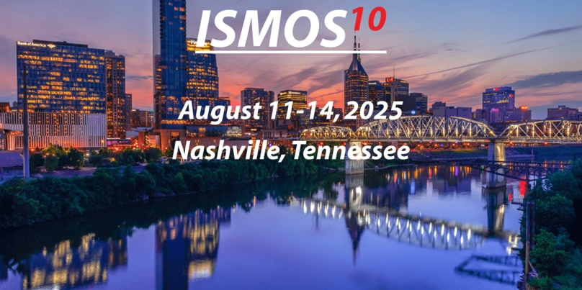
DATE
NAME
Title
ADDRESS
Dear NAME
We are pleased to invite you to the ISMOS Conference 2025(https://ismos-10.org/), to be held from August 11-14, 2025, at the Cordell in Nashville, TN. The conference focuses on molecular biological methods related the Energy sector, and we believe your expertise will contribute greatly to the discussions.
If you have any questions, please reach out to the local organizer, Dora Taggart, CEO, Microbial Insights, Inc. 865.573.8188, dtaggart@microbe.com
We look forward to your participation and hope to hear from you soon. Should you need further details, please do not hesitate to contact us.
President and CEO
Microbial Insights, Inc.
Office: 865-573-8188 x107 Fax: 865-573-8133
Web: www.microbe.com Email: dtaggart@microbe.com
10515 Research Drive , Knoxville, TN 37932
Sincerely,
Dora M Taggart

Hosting Organization ISMOS 2025


